QUALITY COMPARATOR SERVICE
1626 S Arlington Dr
Seneca, Sc
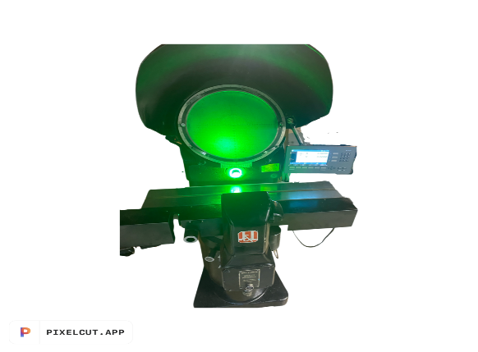
Tel:803-329-5123
PROPOSAL #Aw24919
USED JONES & LAMSON PC-14A OPTICAL COMPARATOR
Refurbished May 2022
- New MX 200 Digital Readout with geometric capabilities
- Standard 14” Glass chart
- New ACU-rite 1um glass scales for X &Y axis
- Long Lasting LED profile illumination
- 20x, 31.25x, 50x, 100x lens available (choice of two)
- Motorized Horizontal drive with 8 inches of travel
- Motorized vertical drive with 4 inches of travel
- Fresh industrial paint
- Fully Refurbished and calibrated, operating at new machine specifications.
- 30-Day return policy
Delivery: Approximately 2 weeks after receipt of order
FOB Seneca, SC
TERM: 80% Down with purchase order, balance due after installation or net 30 with bank and credit references
Machine price as Above…………$15999

